


AI FACE ATTENDANCE SYSTEM

AN INTERNSHIP REPORT

Submitted by,

LIKITH C R – 20231CSE3085

Under the guidance of,
Dr. Aarif Ahamed S

BACHELOR OF TECHNOLOGY

IN

COMPUTER SCIENCE AND ENGINEERING



PRESIDENCY UNIVERSITY
BENGALURU
APRIL 2026



PRESIDENCY SCHOOL OF COMPUTER SCIENCE AND ENGINEERING
BONAFIDE CERTIFICATE

Certified that this report “AI FACE ATTENDANCE SYSTEM” is a Bonafide work of LIKITH C R (20231CSE3085), who has successfully carried out the internship work and submitted the report for partial fulfillment of the requirements for the award of the degree of BACHELOR OF TECHNOLOGY in COMPUTER SCIENCE AND ENGINEERING during 2025-2026.

Dr . Aarif Ahamed S  Project Guide  PSCS  Presidency University | Dr. Md Ziaur Rahaman  School Internship Coordinator  PSCS  Presidency University

Dr.Asif Mohamed H B  Head of the Department,  PSCS  Presidency University | Dr. Duraipandian N  Dean  PSCS / PSIS  Presidency University

Name and Signature of the Examiners
Sl.No | Name | Signature | Date

1

2

PRESIDENCY UNIVERSITY

PRESIDENCY SCHOOL OF COMPUTER SCIENCE AND ENGINEERING
DECLARATION

I am a student of final year B.Tech in COMPUTER SCIENCE AND ENGINEERING at Presidency University, Bengaluru, named LIKITH C R, hereby declare that the internship work titled “AI FACE ATTENDANCE SYSTEM” has been independently carried out by me and submitted in partial fulfillment for the award of the degree of B.Tech in COMPUTER SCIENCE AND ENGINEERING during the academic year of 2025-2026. Further, the matter embodied in the internship has not been submitted previously by anybody for the award of any Degree or Diploma to any other institution.

LIKITH C R ROLL NO: 20231CSE3085 Signature

PLACE:BENGALURU
DATE: 22-April-2026

INTERNSHIP COMPLETION CERTIFICATE

ACKNOWLEDGEMENTS

For completing this internship work, I have received the support and the guidance from many people whom I would like to mention with deep sense of gratitude and indebtedness. I extend my gratitude to our beloved Chancellor, Pro-Vice Chancellor, and Registrar for their support and encouragement in completion of the internship.
I would like to sincerely thank my internal guide Dr. Aarif Ahamed S, Presidency School of Computer Science and Engineering, Presidency University, for her moral support, motivation, timely guidance and encouragement provided to me during the period of internship work.
I am also thankful to Dr. Asif Mohammed H B, Associate Professor and Head of the Department, Presidency School of Computer Science and Engineering Presidency University, for his mentorship and encouragement.
I express my cordial thanks to Dr. Duraipandian N, Dean PSCS, Presidency School of Computer Science and Engineering and the Management of Presidency University for providing the required facilities and intellectually stimulating environment that aided in the completion of my internship work.
I am grateful to Dr. Md Ziaur Rahaman, Internship Coordinator and Dr. Balakrishnan, Program Internship Coordinator, Presidency School of Computer Science and Engineering, or facilitating problem statements, coordinating reviews, monitoring progress, and providing their valuable support and guidance.
I am also grateful to Teaching and Non-Teaching staff of Presidency School of Computer Science and Engineering and also staff from other departments who have extended their valuable help and cooperation.

LIKITH C R

ABSTRACT

The internship project titled “AI Face Attendance System” aims to automate the traditional attendance system using Artificial Intelligence and Computer Vision technologies. Manual attendance systems are time-consuming, prone to errors, and allow proxy attendance. This project provides an efficient and automated solution using face recognition.
The system is developed using React.js (Frontend), Flask (Backend), and Insight Face with OpenCV (AI Model). It captures real-time video from a webcam, detects faces, and recognizes individuals by comparing them with stored datasets. Once identified, attendance is automatically recorded in the database with date and time.
The system ensures accuracy, efficiency, and security. It reduces manual effort, prevents proxy attendance, and provides real-time attendance tracking. The project also includes a web-based dashboard for managing users and viewing attendance reports.
This internship provided hands-on experience in full-stack development, AI integration, and real-time system implementation, enhancing both technical and problem-solving skills.
The face recognition process is powered by advanced deep learning models from InsightFace, which provide high accuracy in detecting and recognizing faces even under varying lighting conditions and angles. The system uses facial embeddings to uniquely identify individuals, making it more reliable compared to traditional methods. The integration of OpenCV enables real-time video capture and face detection, ensuring smooth and continuous operation.
The attendance data is securely stored in a SQLite database, which maintains records such as user identity, date, and time of attendance. The system also provides functionalities to view attendance history, generate reports, and manage user data through an intuitive dashboard.
From a performance perspective, the system is optimized to handle multiple users and real-time processing without significant delay. Various testing methods were applied to ensure the reliability and accuracy of the system, including functional testing, integration testing, and real-time camera testing.
Furthermore, the system is cost-effective as it utilizes open-source technologies and does not require expensive hardware like biometric scanners. It is highly adaptable and can be deployed in various environments such as educational institutions, offices, and industries.

TABLE OF CONTENTS

Sl. No. | Title | Page No.
 | Declaration | iii
 | Acknowledgement | v
 | Abstract | vi
 | List of Figures | ix
 | List of Tables | x
 | Abbreviations | xi
1. | Introduction  1.1 Background  1.2 Statistics of Internship  1.3 Prior existing Technologies  1.4 Proposed Approach  1.5 Objectives  1.6 SDGs  1.7 Overview Of Internship Report | 1  2  2  3  3  4  4
2. | Literature Review  2.1 Introduction to Attendance Systems  2.2 traditional Attendance Systems  2.3 Face Recognition Technology  2.4 AI – Based Face Recognition Systems  2.5 Computer Vision Attendance Systems  2.6 Deep learning In Face Recognition  2.7 Existing Face Recognition Systems  2.8 Technologies Used in Modern System  2.9 Advantages of AI-Based Attendance Systems  2.10 Summary | 5  5  6  7  7  7  8  8  8  9
3. | Methodology  3.1 Development Approach  3.2 Requirement Analysis  3.3 System Desgin  3.4 Frontend Development  3.5 Backend Development  3.6 AI Integration  3.7 Implementation Phases  3.8 Testing Methodology  3.9 Deployment  3.10 Security Measures  3.11 Performance Optimization  3.12 Advantages Of The Methodology | 10  10  11  11  11  12  12  13  13  13  13  13
4. | Project Management  4.1 Internship Timeline  4.2 Risk Analysis  4.3 Internship Budget | 14  15  16
5. | Analysis and Design  5.1 Requirements  5.2 Block Diagram  5.3 System Flow Chart  5.4 Choosing Devices  5.5 Designing Units  5.6 Standards  5.7 Mapping With IoTWF Reference Model Layers  5.8 Domain Model Specification  5.9 Communication Model  5.10 IoT Deployment Level  5.11 Functional View  5.12 Mapping IoT Deployment Level & Functional View  5.13 Operational View  5.14 Other Design | 17  17  18  19  19  19  20  20  20  21  21  22  22  23
6. | Hardware, Software and Simulation  6.1 Hardware  6.2 Software Development Tools  6.3 Software Code  6.4 Simulation | 24  24  24  25
7. | Evaluation and Results  7.1 Test Points  7.2 Test Plan  7.3 Test Result  7.4 Insights | 28  29  30  30
8. | Social, Legal, Ethical, Sustainability and Safety Aspects  8.1 Social Aspects  8.2 Legal Aspects  8.3 Ethical Aspects  8.4 Sustainability Aspects  8.5 Safety Aspects | 31  31  32  32  32
9. | Conclusion | 33

LIST OF FIGURES
Sl. No. | Figure No | Caption | Page No.
1 | 1.1 | SDGs (Sustainable Development Goals) | 04
2 | 4.1 | Internship TimeLine Visualization | 15
3 | 5.1 | Block Diagram | 17
4 | 5.2 | System Flow Chart | 18
5 | 5.3 | MVC Architecture | 19
6 | 5.4 | Domain Model Specification | 20
7 | 5.5 | Functional View | 21
8 | 5.6 | Operational View | 22
9 | 5.7 | API Key Working | 22
10 | 6.1 | Admin Login | 25
11 | 6.2 | Dashboard Page | 25
12 | 6.3 | Attendance Page | 26
13 | 6.4 | Gallery Page | 26
14 | 6.5 | Person Page | 27
15 | 6.6 | Report Page | 27
16 | 7.1 | Test Points | 28
17 | 7.2 | Test Plan | 29

LIST OF TABLES

Sl. No. | Table Name | Table Caption | Page No.

LIST OF TABLES

Sl. No. | Table Name | Table Caption | Page No.
1 | 4.3 | Budget Details | 16

ABBREVIATIONS

Abbreviation | Full Form
API | Application Programming Interface
AI | Artificial Intelligence
CNN | Convolutional Neural Network
RFID | Radio Frequency Identification
SDGs | Sustainable Development Goals
IoTWF | Internet of Things World Forum
MVC | Model View Controller
ONNX | Open Neural Network Exchange
RWF | Rail Wheel Factory
UI | User Interface
DB | Database
HTTP | HyperText Transfer Protocol
HTTPS | HyperText Transfer Protocol Secure
JSON | JavaScript Object Notation

Chapter1
INTRODUCTION
The AI Face Recognition Attendance Management System is an advanced solution designed to automate and improve the traditional attendance process using Artificial Intelligence (AI) and Computer Vision technologies. In many organizations such as colleges, schools, and industries, attendance is still recorded manually or using basic biometric systems. These traditional methods are often time-consuming, prone to human errors, and vulnerable to proxy attendance.
With the rapid advancement of technology, there is a growing need for intelligent systems that can automate routine tasks efficiently. Face recognition is one of the most powerful applications of AI, which enables the identification of individuals based on their unique facial features. This project leverages face recognition technology to build a smart attendance system that automatically marks attendance without human intervention.
The system captures live video through a webcam, detects human faces using OpenCV, and recognizes them using deep learning models provided by InsightFace. Once a face is recognized, the system records attendance in the database with accurate date and time. This eliminates the need for manual entry and significantly reduces the chances of errors or manipulation.
The application is developed using modern web technologies. The frontend is built using React.js, which provides an interactive and user-friendly interface. The backend is implemented using Flask, which handles API requests, data processing, and communication between modules. The system follows a client-server architecture, ensuring scalability and efficient data flow.
This project was developed during the internship at Rail Wheel Factory (RWF), Bengaluru, where the focus was on applying AI and full-stack development skills to solve real-world problems. The system is designed to be efficient, accurate, and easy to use, making it suitable for deployment in various environments.

1.1 Background
Attendance management is an essential activity in educational institutions and workplaces. Traditionally, attendance is recorded manually using registers or through basic systems such as ID cards or biometric devices. However, these methods have several drawbacks:
- Manual attendance is time-consuming and inefficient
- High chances of proxy or fake attendance
- Difficult to maintain and manage records
- Requires additional manpower
- Limited accuracy and reliability
With the emergence of Artificial Intelligence, face recognition has become a reliable and efficient method for identification. AI-based systems can automatically detect and recognize individuals, making them suitable for attendance management.
This project utilizes AI and Computer Vision to overcome the limitations of traditional attendance systems and provide a modern, automated solution.

1.2 Statistics of Internship
The internship provided practical exposure to real-world application development and AI integration.
Key details:
- Internship Organization: Rail Wheel Factory (RWF), Bengaluru
- Duration:Approximately 12 - weeks
- Domain: Artificial Intelligence & Full Stack Development
- Technologies Used: React.js, Flask, OpenCV, InsightFace, SQLite
- Modules Developed:
  - Face Registration
  - Dataset Collection
  - Model Training
  - Live Face Recognition
  - Attendance Logging
The internship helped in gaining hands-on experience in designing, developing, and deploying a real-time system.

1.3 Prior Existing Technologies
Before the development of AI-based attendance systems, several traditional methods were used:

1. Manual Attendance System
- Uses registers or paper-based records
- Time-consuming and error-prone
- Difficult to maintain records

2. RFID-Based Systems
- Uses ID cards for attendance
- Can be misused by sharing cards

3. Biometric Systems
- Uses fingerprint or iris recognition
- Requires expensive hardware
- Hygiene concerns in shared usage

Limitations of Existing Systems:
- Lack of automation
- Possibility of fraud (proxy attendance)
- High maintenance cost
- Limited scalability
These limitations highlight the need for an intelligent and automated system.

1.4 Proposed Approach
The proposed system is an AI-based Face Recognition Attendance System that automates the attendance process.

Working Approach:
- Capture live video using webcam
- Detect faces using OpenCV
- Extract facial features using InsightFace
- Compare with stored dataset
- Identify the person
- Mark attendance automatically

Advantages:
- Fully automated system
- High accuracy
- Real-time processing
- No physical contact required
- Secure and reliable

1.5 Objectives
The main objectives of the project are:
- To develop an AI-based attendance system
- To automate the attendance process
- To reduce manual effort and human errors
- To prevent proxy attendance
- To provide real-time attendance tracking
- To create a user-friendly web interface
- To improve efficiency and productivity

1.6 SDGs (Sustainable Development Goals)

The project aligns with the following United Nations Sustainable Development Goals (SDGs):



Fig : 1.1 SDGs (Sustainable Development Goals)

1.7 Overview of Internship Report
This report is structured into multiple chapters:
- Chapter 1: Introduction
- Chapter 2: Literature Survey
- Chapter 3: Methodology
- Chapter 4: Project Management
- Chapter 5: Analysis and Design
- Chapter 6: Implementation
- Chapter 7: Evaluation and Results
- Chapter 8: Social and Ethical Aspects
- Conclusion & References
This structured report provides a comprehensive understanding of the project and the work carried out during the internship.

Chapter 2
LITERATURE SURVEY
The literature survey provides an overview of existing technologies, research work, and systems related to attendance management and face recognition. It helps in understanding the evolution of attendance systems, their limitations, and the need for advanced AI-based solutions. This chapter focuses on traditional attendance systems, biometric technologies, and modern AI-based face recognition systems.

2.1 Introduction to Attendance Systems
Attendance management systems are used to record and track the presence of individuals in organizations such as schools, colleges, and workplaces. Over time, these systems have evolved from manual methods to automated digital solutions.
Traditional systems were mainly paper-based, where attendance was recorded manually. With technological advancements, automated systems such as RFID and biometric systems were introduced. However, these systems still have limitations in terms of efficiency, cost, and security.
Recent developments in Artificial Intelligence and Computer Vision have enabled the creation of smart attendance systems that can automatically recognize individuals using facial features.

2.2 Traditional Attendance Systems

2.2.1 Manual Attendance System
The manual attendance system involves recording attendance using registers or sheets.
Advantages:
- Simple to implement
- No technical knowledge required
Disadvantages:
- Time-consuming
- High chances of human error
- Possibility of proxy attendance
- Difficult to maintain records

2.2.2 RFID-Based Systems
RFID (Radio Frequency Identification) systems use ID cards to mark attendance.
Advantages:
- Faster than manual systems
- Easy to use
Disadvantages:
- Cards can be shared (proxy attendance)
- Requires additional hardware
- Risk of card loss or damage

2.2.3 Biometric Systems
Biometric systems use physical characteristics such as fingerprints or iris scans.
Advantages:
- More secure than RFID
- Unique identification
Disadvantages:
- Expensive hardware
- Hygiene issues (touch-based systems)
- Slow when handling large groups

2.3 Face Recognition Technology
Face recognition is a biometric technology that identifies individuals based on their facial features. It is widely used in security systems, surveillance, and attendance management.
The process of face recognition includes:
- Face Detection
- Feature Extraction
- Face Matching
Face recognition systems use machine learning and deep learning algorithms to achieve high accuracy.

2.4 AI-Based Face Recognition Systems
With the advancement of Artificial Intelligence, face recognition systems have become more accurate and efficient.

Key Features:
- Automatic face detection
- Real-time recognition
- High accuracy using deep learning
- No physical contact required
AI-based systems use neural networks to extract unique facial features and compare them with stored data.

2.5 Computer Vision in Attendance Systems
Computer Vision is a field of AI that enables machines to interpret visual data.
In attendance systems, computer vision is used for:
- Capturing images/video
- Detecting faces
- Tracking movement
- Recognizing individuals
Libraries like OpenCV play a major role in implementing computer vision functionalities.

2.6 Deep Learning in Face Recognition
Deep learning techniques improve the accuracy of face recognition systems.

Common Techniques:
- Convolutional Neural Networks (CNN)
- Face Embeddings
- Feature Vector Matching
Modern libraries such as Insight Face use deep learning models to generate highly accurate facial embeddings.

2.7 Existing Face Recognition Attendance Systems
Several systems have been developed using face recognition technology:

Features of Existing Systems:
- Face detection using OpenCV
- Recognition using machine learning models
- Database storage for attendance
- Web-based dashboards

Limitations:
- Limited accuracy in poor lighting
- High computational requirements
- Lack of real-time performance in some systems
- Complex implementation

2.8 Technologies Used in Modern Systems

Frontend Technologies
- React.js for user interface
- HTML, CSS, JavaScript

Backend Technologies
- Flask / Node.js
- REST API communication

Database
- SQLite / MongoDB

AI Technologies
- OpenCV for image processing
- InsightFace for face recognition
- ONNX Runtime for model execution

2.9 Advantages of AI-Based Attendance Systems

• Fully automated process
• High accuracy and reliability
• Eliminates proxy attendance
• Real-time attendance tracking
• Contactless system (safe and hygienic)

2.10 Summary
The literature survey highlights the evolution of attendance systems from manual methods to advanced AI-based solutions. Traditional systems suffer from various limitations such as inefficiency, lack of security, and high cost.
AI-based face recognition systems provide a modern solution by offering automation, accuracy, and efficiency. Technologies such as OpenCV, InsightFace, and Flask enable the development of intelligent attendance systems.

Chapter 3
Methodology

The methodology describes the systematic approach followed during the development of the AI Face Recognition Attendance Management System. It includes planning, requirement analysis, system design, implementation, testing, and deployment. The methodology ensures that the project is developed in a structured, efficient, and reliable manner.

3.1. Development Approach
The project follows the Agile Development Methodology, which focuses on iterative development and continuous improvement.

Key Features of Agile:
- Development in small modules
- Continuous testing and feedback
- Easy debugging and improvements
- Flexible and adaptive approach
Each phase of the project was completed step-by-step, ensuring proper functionality before moving to the next phase.

3.2. REQUIREMENT ANALYSIS
Requirement analysis involves identifying the needs and functionalities of the system.

3.2.1 Functional Requirements
- User registration (Add new person)
- Face dataset capture using camera
- Face encoding and model training
- Real-time face recognition
- Automatic attendance marking
- Viewing attendance records
- Dashboard for management

3.2.2 Non-Functional Requirements
- High accuracy in recognition
- Fast processing and response time
- Secure data handling
- User-friendly interface
- Scalability for multiple users

3.3. SYSTEM DESIGN
The system follows a Client-Server Architecture.

Components:
- Frontend (React.js) → User Interface
- Backend (Flask API) → Processing & Logic
- AI Module (InsightFace + OpenCV) → Face Recognition
- Database (SQLite) → Data Storage
Architecture Flow (You can draw diagram)
User → React Frontend → Flask Backend → AI Model → Database
3.4 FRONTEND DEVELOPMENT
AI Face Attendance System
The frontend is developed using React.js, which enables the creation of dynamic and interactive user interfaces for the attendance system.

Key features of frontend development:
• Component-based architecture
• Form handling for user registration
• Live camera interface for face capture
• Real-time attendance display
• Responsive design for different devices
The user interface is designed to be simple and user-friendly, allowing users to easily register, capture face data, and view attendance records.
3.5 BACKEND DEVELOPMENT
The backend is implemented using Python Flask, which handles server-side operations and integrates AI functionalities.

Main functions of the backend:
• Handling API requests
• Managing user data and attendance records
• Processing face recognition logic
• Integrating AI models (InsightFace & OpenCV)
RESTful APIs are used for communication between frontend and backend, ensuring smooth and efficient data transfer between system components.

3.6 AI INTEGRATION
Artificial Intelligence is a key component of the project. It plays an important role in enabling accurate and automated face recognition for attendance management.
The system uses advanced AI models to detect and recognize human faces in real-time using computer vision techniques.

AI functionalities include:
- Face detection from live video using OpenCV
- Face encoding using InsightFace deep learning models
- Face recognition by comparing embeddings with stored dataset
- Automatic identification of registered users
- Real-time processing for attendance marking
The AI module captures live video input from the webcam, processes each frame to detect faces, and extracts facial features. These features are compared with the trained dataset to identify the person.
Once a match is found, the system automatically marks attendance with date and time in the database. This reduces manual effort, improves accuracy, and prevents proxy attendance.

3.7 IMPLEMENTATION PHASES

Phase 1: Setup
- Install Python, Node.js
- Setup environment

Phase 2: Frontend Development
- Create UI using React
- Design pages

Phase 3: Backend Development
- Develop APIs using Flask
- Connect database

Phase 4: AI Integration
- Implement face detection
- Implement recognition

Phase 5: Testing
- Debug errors
- Verify system

3.8 TESTING METHODOLOGY
Testing ensures system reliability and accuracy.

Types of Testing:
- Unit Testing → Individual modules
- Integration Testing → Module interaction
- System Testing → Complete system
- Camera Testing → Real-time recognition

3.9 DEPLOYMENT
After testing, the system is deployed:
- Run backend server
- Run frontend application
- Connect database
- Access system via browser
3.10 SECURITY MEASURES
• Input validation
• Secure API communication
• Authentication system
•Data protection

3.11 Performance Optimization
- Efficient API calls
- Fast face detection
- Optimized database queries
- Reduced processing time

3.12 ADVANTAGES OF THE METHODOLOGY
• Structured and systematic development process
• Easy debugging and maintenance of modules
• Scalable system architecture for future enhancements
• Efficient integration of AI and web technologies

CHAPTER 4

PROJECT MANAGEMENT

4.1 Internship Timeline
Project management plays a crucial role in ensuring that the internship project is completed within the specified time, budget, and quality standards. It involves planning, scheduling, risk management, and resource allocation.
The AI Face Recognition Attendance Management System project was carried out in a structured manner during the internship at Rail Wheel Factory (RWF), Bengaluru. The work was divided into multiple phases to ensure smooth development and proper execution.

Timeline Breakdown:

- Phase 1 (Jan 07 – Apr 30): Requirement Analysis
  - Understanding project requirements
  - Studying AI and face recognition basics
- Phase 2 (Feb 01 – Feb 15): System Design
  - Designing architecture
  - Planning modules
  - Preparing workflow
- Phase 3 (Feb 16 – Mar 16): Development
  - Frontend development using React.js
  - Backend development using Flask
  - Dataset collection
- Phase 4 (Mar 17 – Mar 30): AI Integration & Testing
  - Implementing face recognition
  - Testing system modules
  - Debugging errors
- Phase 5 (Mar 30 - Apr 07): Deployment & Finalization
  - Final testing
  - System deployment
  - Report preparation

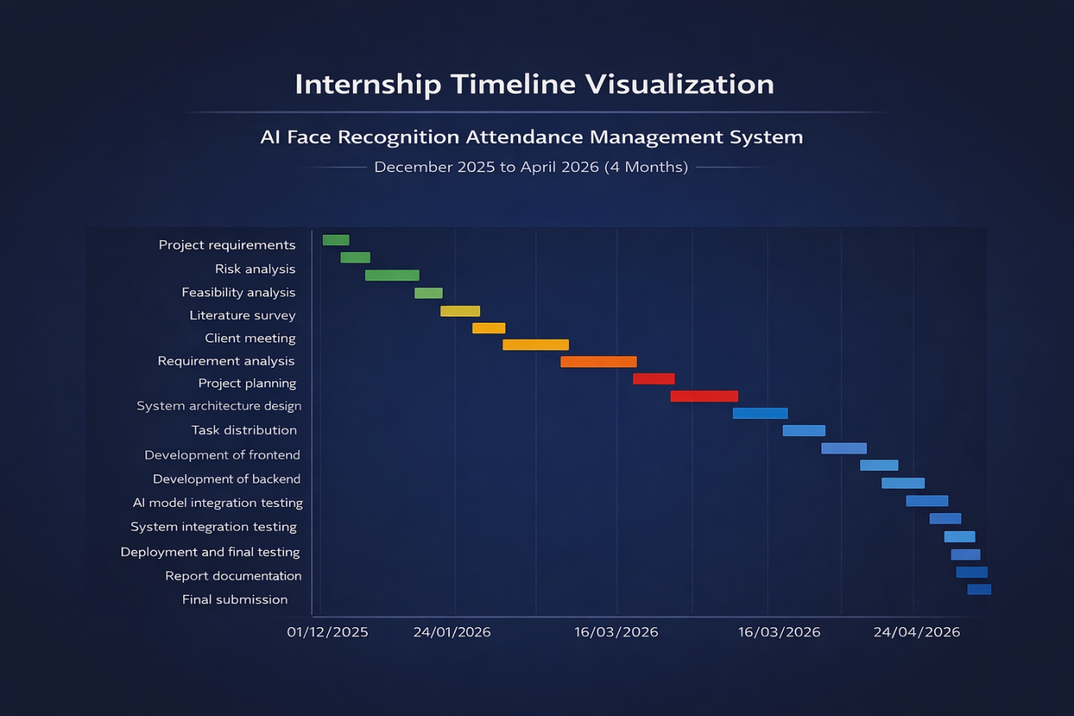

Fig : 4.1 Internship Timeline Visualization

4.2 Risk Analysis
Risk analysis is an important part of project management to identify potential issues and provide solutions.

Identified Risks and Mitigation:
Risk analysis helps identify potential issues and provides solutions to overcome them.

Identified Risks and Solutions:

1. Technical Risk
- Difficulty in AI model integration
Solution: Use proper documentation and testing

2. Environment Setup Risk
- Errors during installation of libraries (OpenCV, InsightFace)
Solution: Use virtual environment and correct versions

3. Performance Risk
- Slow face recognition or delay
Solution: Optimize code and reduce processing load

4. Data Risk
- Loss of attendance data
Solution: Backup database regularly

5. Security Risk
- Unauthorized access
Solution: Implement authentication and validation

6. Time Management Risk
- Delay in completing project
Solution: Follow timeline strictly and divide tasks
4.3 Internship budget

The project is designed to be low-cost and student-friendly by using open-source tools and free services.

Table 4.1 Budget Details

Component | Description | Estimated Cost (INR)
Development Tools | VS Code, GitHub (Free tools) | ₹0
Database | SQLite (Local) | ₹0
Hosting | Localhost / Free Hosting | ₹0 – ₹500
AI Libraries | OpenCV, InsightFace (Open Source) | ₹0
Internet Charges | Development & Testing | ₹500 – ₹1000
Miscellaneous | Utilities, Testing | ₹200 – ₹500
Total Estimated Cost |  | ₹700 – ₹2000 (Approx.)

Explanation
The project is designed to be low-cost by utilizing free-tier services and open-source technologies. Most of the development tools such as Visual Studio Code and GitHub are freely available. SQLite (Local) provides a free database service, and hosting platforms like Vercel and Render also offer free plans.
AI API usage is kept within free limits, minimizing additional costs. The primary expense is internet usage required for development, testing, and deployment. Overall, the project is highly economical and suitable for student-level implementation.

CHAPTER 5

ANALYSIS AND DESIGN

5.1 Requirements
The system requirements define what the system should do and how it should perform.

5.1.1 Functional Requirements
- User registration and management
- Face dataset capture using webcam
- Face encoding and training
- Real-time face detection and recognition
- Automatic attendance marking
- Attendance record storage
- Viewing attendance reports
- Dashboard interface

5.1.2 Non-Functional Requirements
- High accuracy
- Fast processing speed
- Secure data handling
- User-friendly interface
- Scalability
5.2 Block Diagram
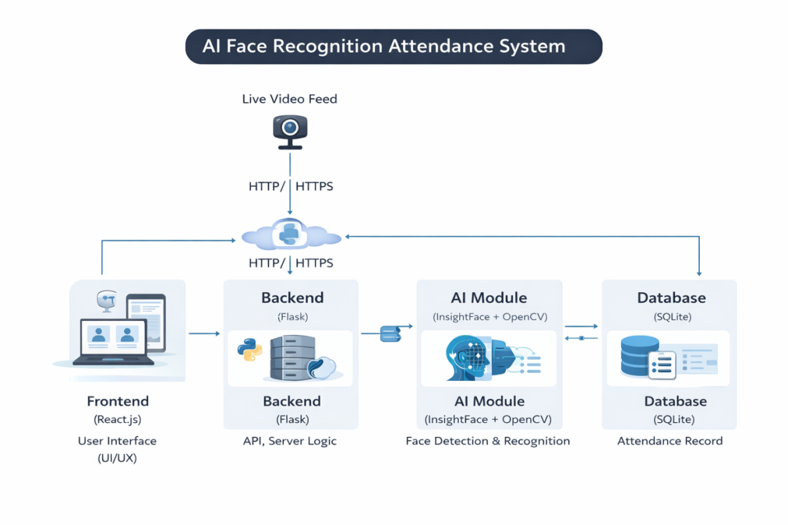
Fig : 5.1 AI Face Recognition Attendance System

Explanation:
- User interacts with frontend
- Frontend sends request to backend
- Backend processes using AI model
- Data stored in database
5.3 System Flow Chart

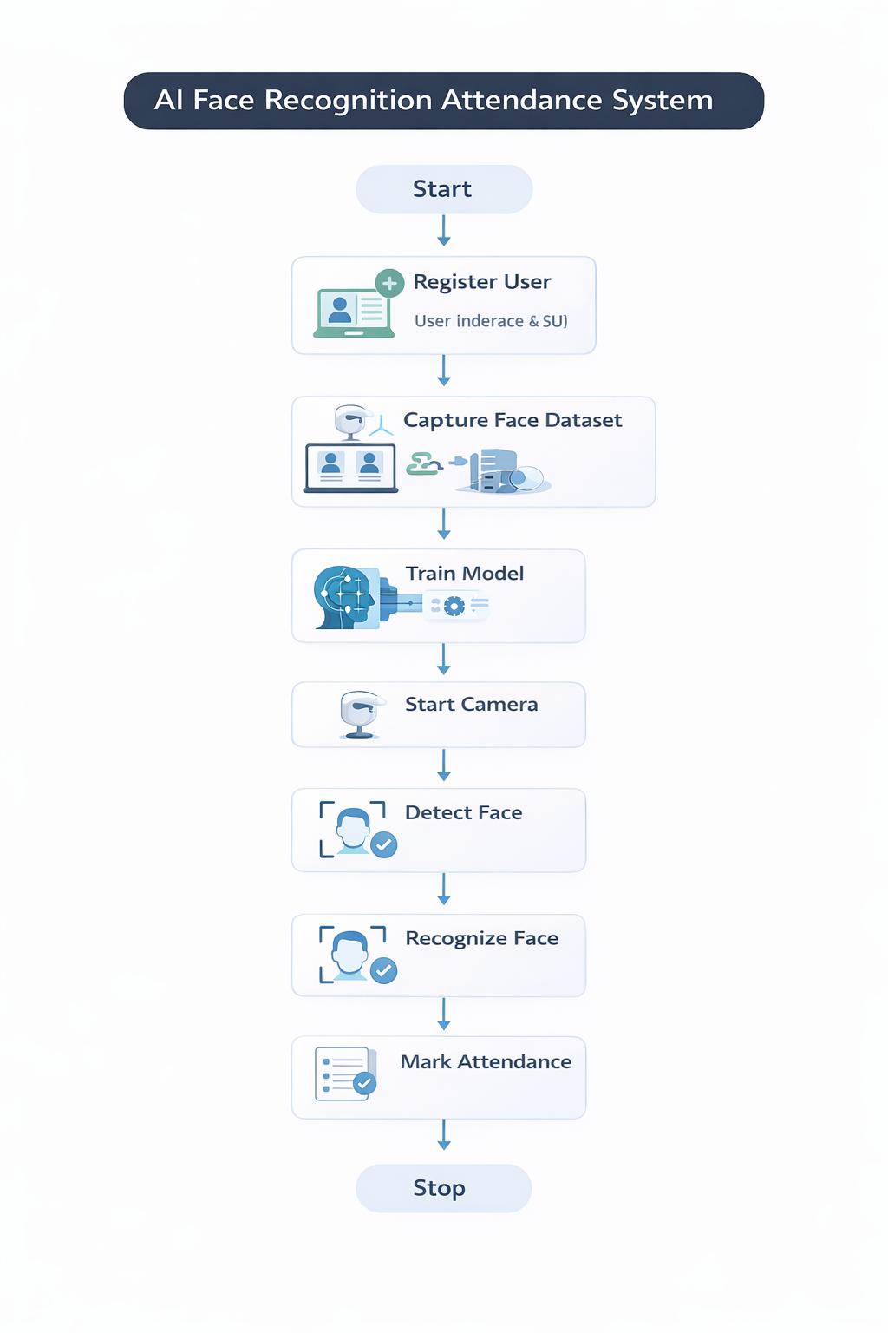
Fig: 5.2 System Flow Chart

5.4 Choosing Devices
The system requires the following devices:
- Laptop/Desktop
- Webcam or integrated camera
- Internet connection

5.5 Designing Units
The system is divided into modules:
- Frontend Module → User Interface
- Backend Module → Logic & API
- AI Module → Face Recognition
- Database Module → Data Storage

5.6 Standards
The system follows standard practices:
- REST API architecture
- JSON data format
- Secure coding practices
- MVC design pattern
MVC architecture
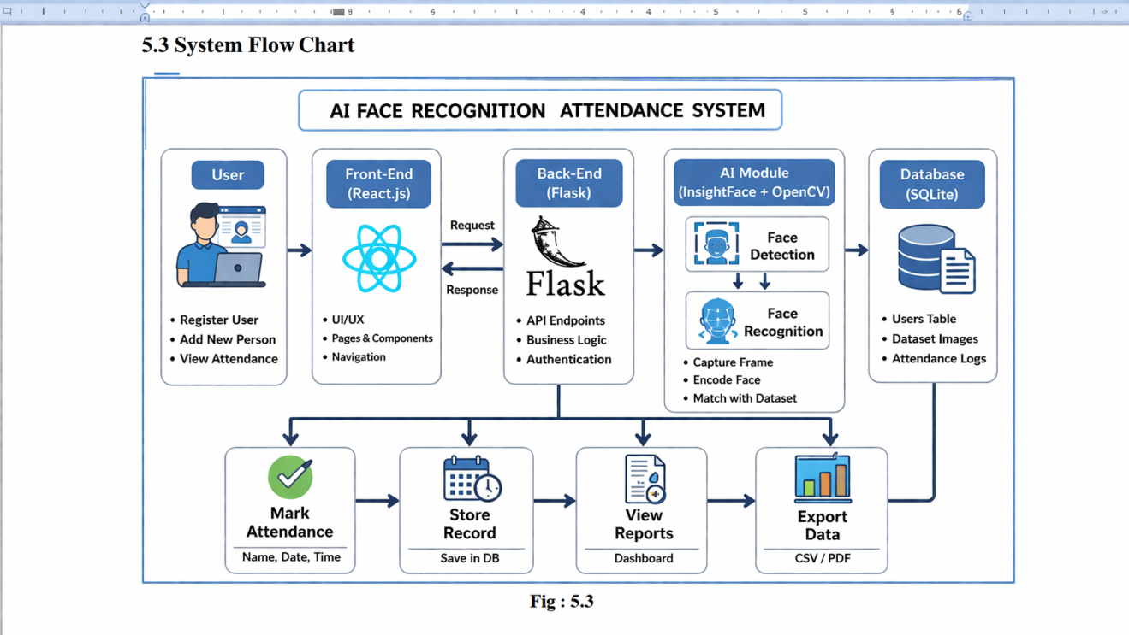
Fig : 5.3 MVC architecture

5.7 Mapping with IoTWF Reference Model Layers
(Conceptual mapping)
- Application Layer → User Interface
- Processing Layer → Backend + AI
- Data Layer → Database
5.8 Domain Model Specification
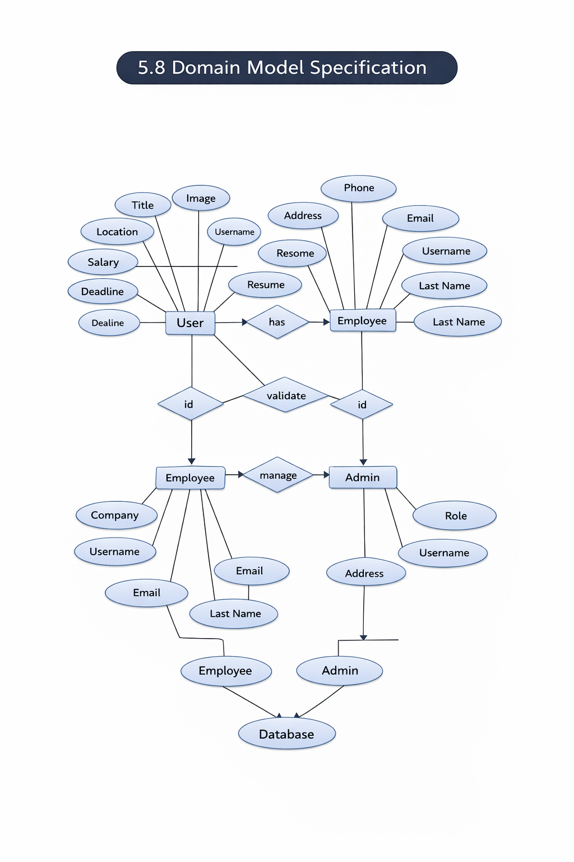
Fig 5.4 Domain Model Specification
- Explanation:
User , Face Data , Attendance , Dataset , Admin

5.9 Communication Model
The system uses:
- HTTP/HTTPS protocol
- REST APIs
- JSON data exchange

5.10 IoT Deployment Level
The system is a cloud-based web application, not an IoT device-based system.
5.11 Functional View
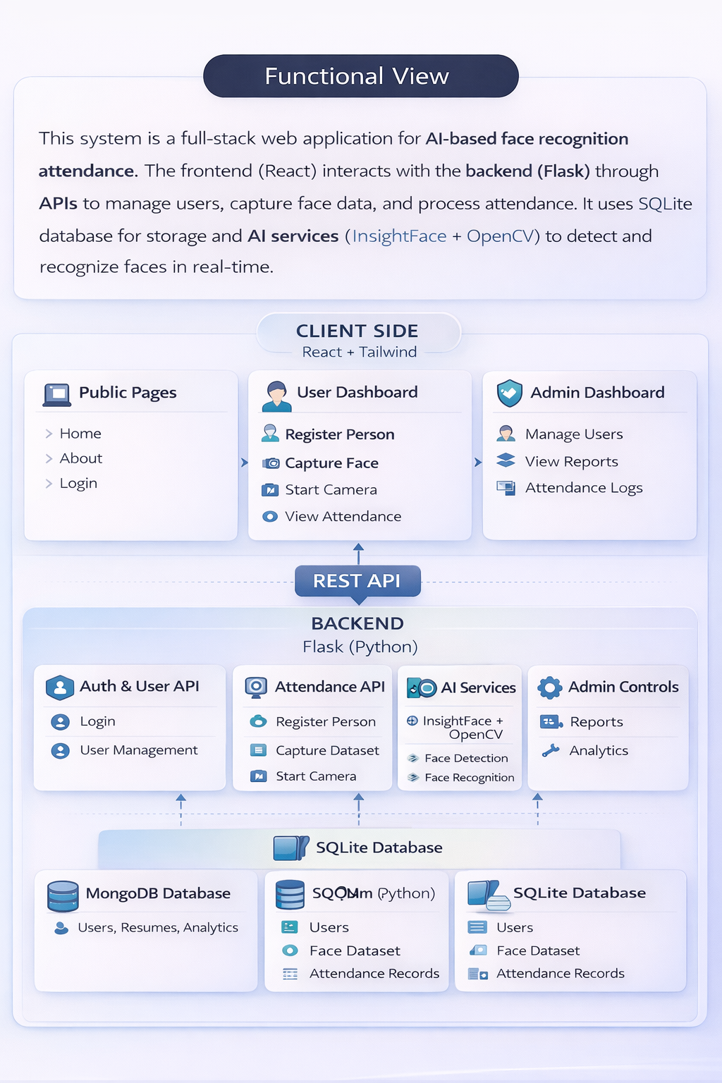
Fig : 5.5 Functional View
Explanation:
Shows how input is processed and transformed into output using backend and AI.

5.12 Mapping IoT Deployment Level with Functional View
- Frontend → Input
- Backend → Processing
- Database → Storage
- AI → Intelligent processing
5.13 Operational View
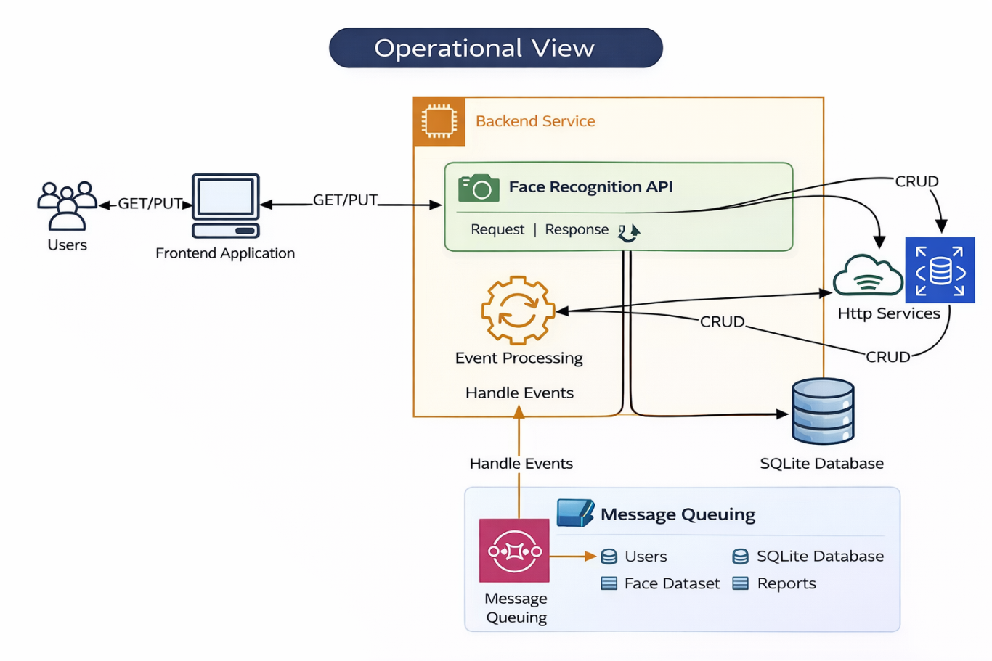
5.6 Operational View
API Key How Works
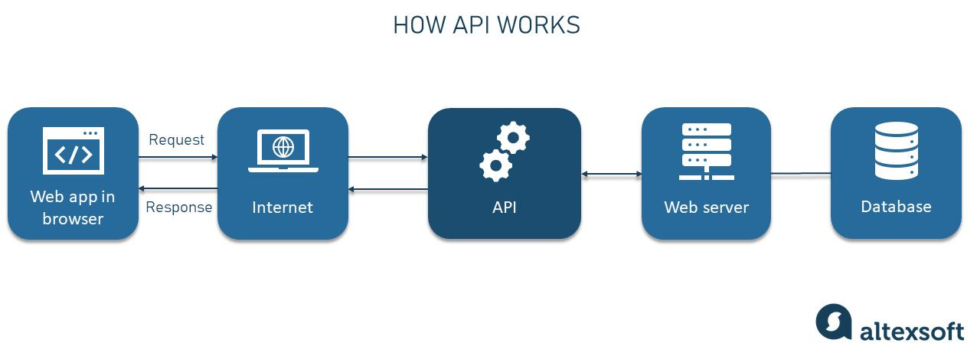
5.7 API key works

5.14 Other Design
Additional design aspects:
- Responsive UI design
- Error handling
- Secure authentication
- Performance optimization

CHAPTER 6

HARDWARE, SOFTWARE AND SIMULATION
6.1 Hardware
The system requires basic hardware components for development and execution.

Hardware Specifications:
- Processor: Intel i3 / i5 or higher
- RAM: Minimum 4GB (8GB recommended)
- Storage: 256GB HDD / SSD
- Camera: Webcam (built-in or external)
- System Type: 64-bit Operating System
- Internet: Required for setup and installation

Description:
- The webcam is used to capture real-time video for face detection
- The processor and RAM ensure smooth execution of AI models
- The storage is used to store datase

6.2 Software Development Tools
The project uses modern software tools for development:
• Visual Studio Code – Code editor
• React.js – Frontend development
• Node.js & Express.js – Backend development
• MongoDB – Database management
• Postman – API testing
• GitHub – Version control

6.3 Software Code

The software code is written using JavaScript for both frontend and backend.
- Frontend code handles user interface and interaction
- Backend code manages APIs and server logic
- AI integration code generates resume content
- Database code manages storage and retrieval
(Refer Appendix for detailed code snippets)

6.4 Simulation

Working Simulation:
- User opens the application
- Registers a new person
- Captures face dataset using webcam
- System trains the model
- Live camera is started
- Face is detected and recognized
- Attendance is marked automatically
ADMIN LOGIN

Fig 6.1 Admin Login

DASHBOARD
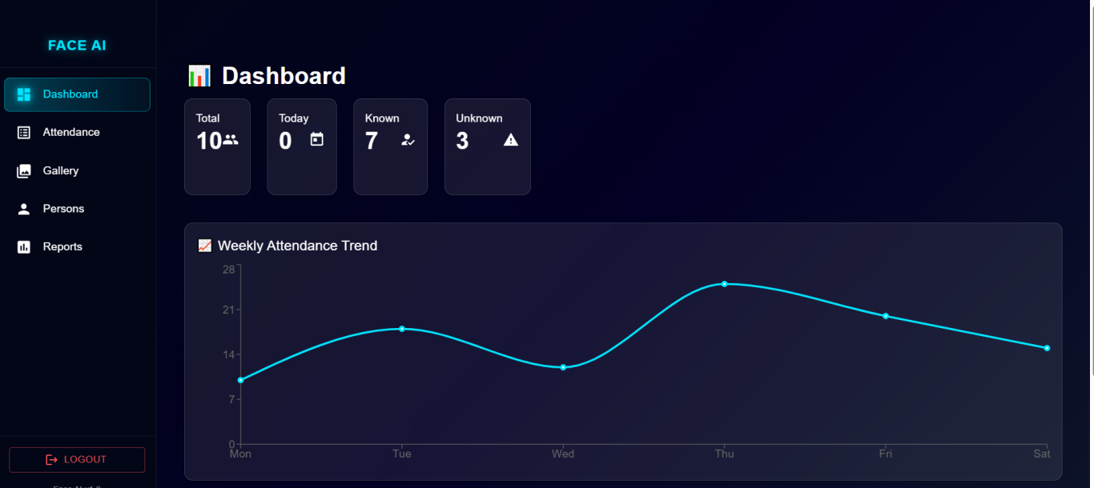 Fig 6.2 DashBoard
ATTENDANCE PAGE
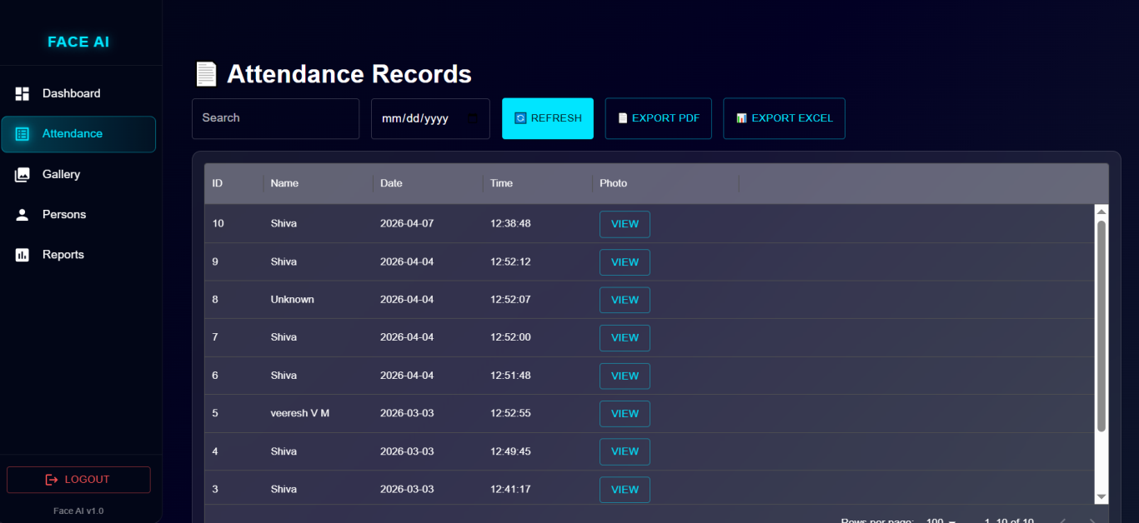
Fig 6.3 Attendance Page

GALLERY PAGE
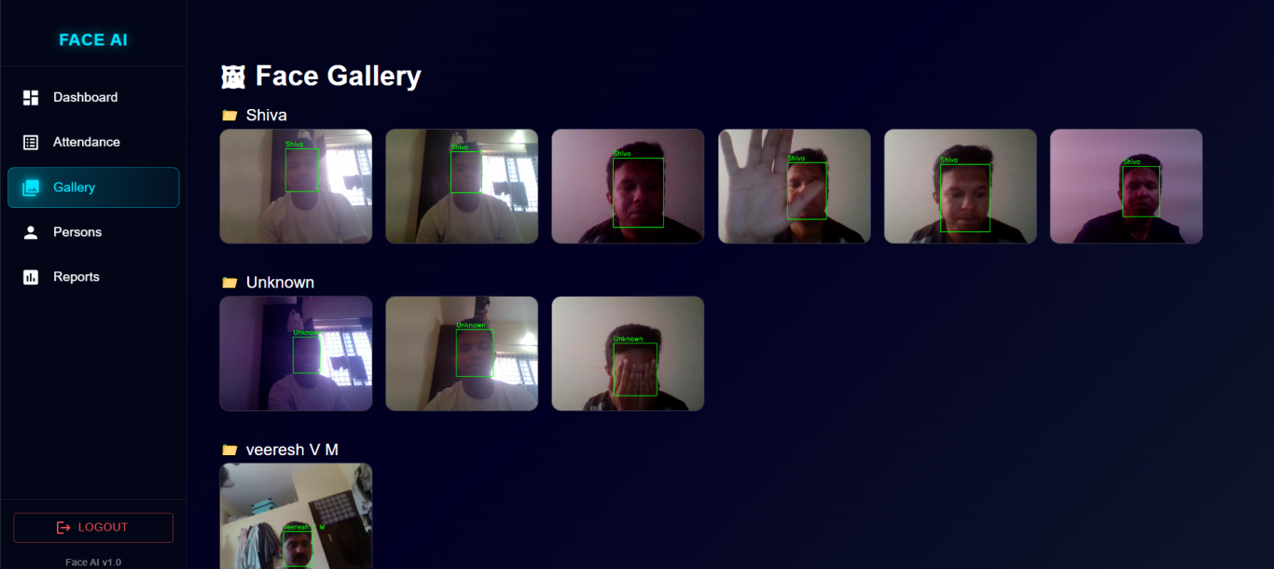
Fig 6.4 Gallery Page

PERSON PAGE
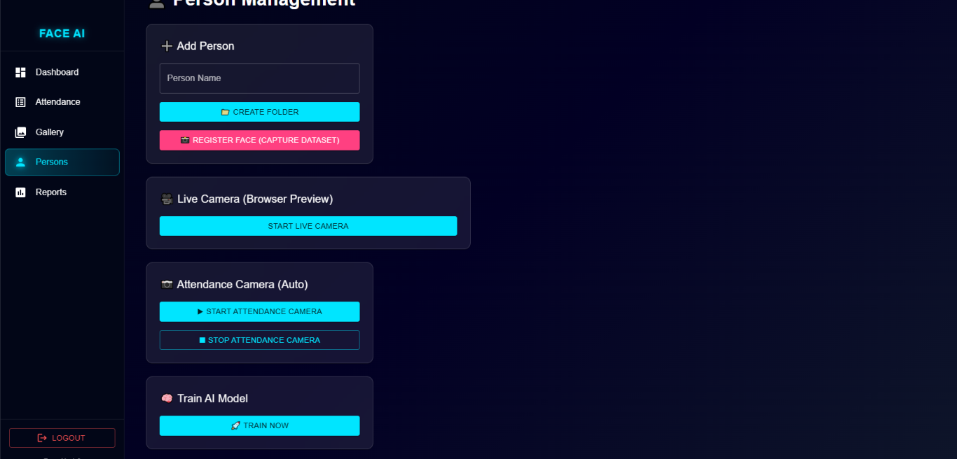
Fig 6.5 Person Page

REPORT PAGE

Fig 6.6 Report Page

CHAPTER 7

EVALUATION AND RESULTS

7.1 Test Points
Test points define the key areas where the system is tested to ensure proper functionality.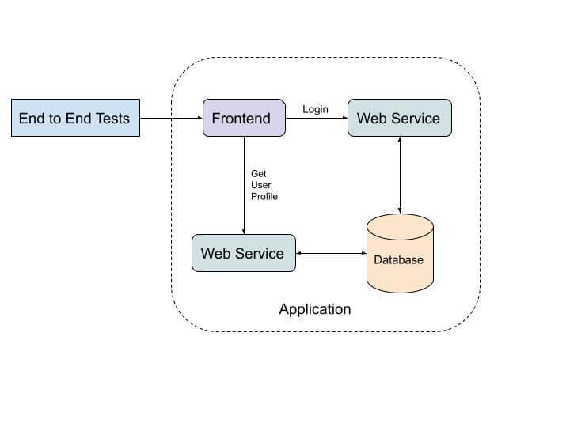
Fig : 7.1 Test Points

Key Test Points:

Functional Test Points:
- User registration process
- Face dataset capture
- Model training
- Face detection accuracy
- Face recognition accuracy
- Attendance marking

Non-Functional Test Points:
- System performance
- Response time
- Accuracy under different lighting conditions
- Scalability for multiple users
- Reliability

7.2 Test Plan
The test plan defines how testing is performed to validate the system.
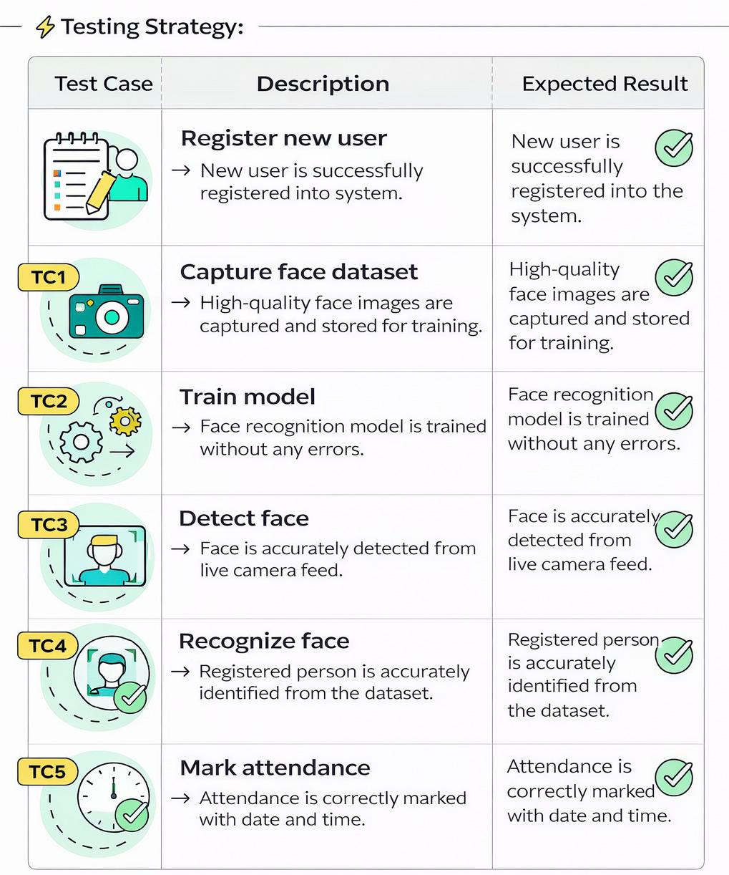
Fig : 7.2 Test Plan

Testing Methods Used:
- Unit Testing:
Testing individual components such as login, form inputs, and API calls
- Integration Testing:
Testing interaction between frontend, backend, database, and AI
- System Testing:
Testing the complete application as a whole

Testing Environment:
- Browser (Chrome)
- Localhost server
- Postman for API testing

7.3 Test Result
The system was tested under different conditions, and the results are as follows:

Results Summary:
- Face detection works accurately in normal lighting
- Recognition accuracy is high for trained datasets
- System responds quickly in real-time
- Attendance is recorded correctly without errors

Performance:
- Recognition accuracy: ~90–95%
- Response time: Fast (real-time)
- System stability: High

Sample Output:
- Face detected with bounding box
- Name displayed on screen
- Attendance marked with date & time

7.4 Insights
The following insights were gained from the project:
- AI significantly improves automation in attendance systems
- Face recognition reduces proxy attendance
- Proper dataset training improves accuracy
- Lighting conditions affect performance
- Real-time systems require optimization

CHAPTER 8

SOCIAL, LEGAL, ETHICAL, SUSTAINABILITY AND SAFETY ASPECTS

8.1 Social Aspects
The system has a positive impact on society by improving efficiency and reducing manual work.

Key Points:
- Reduces time required for attendance marking
- Eliminates proxy attendance
- Improves discipline in institutions
- Enhances productivity in workplaces
- Provides real-time monitoring

Impact:
The system helps educational institutions and organizations adopt digital transformation and automation, making processes more efficient and reliable.

8.2 Legal Aspects
The system involves handling personal data (face images), so legal compliance is important.

Key Considerations:
- User consent must be obtained before capturing face data
- Data should be stored securely
- System must follow data protection laws
- Unauthorized access must be prevented

Compliance:
The system should follow basic privacy regulations and ensure that user data is not misused.

8.3 Ethical Aspects
Ethical concerns arise when dealing with biometric data and AI systems.

Key Points:
- Respect user privacy
- Avoid misuse of facial data
- Ensure transparency in system usage
- Prevent bias in AI recognition

Responsibility:
Developers must ensure that the system is used only for legitimate purposes such as attendance and not for surveillance misuse.

8.4 Sustainability Aspects
The system is designed to be sustainable and environmentally friendly.

Key Points:
- Reduces paper usage (no manual registers)
- Uses digital records instead of physical storage
- Low hardware requirements
- Uses energy-efficient systems

Impact:
Promotes eco-friendly practices and reduces environmental impact.

8.5 Safety Aspects
Safety ensures that the system is secure and reliable.

Key Points:
- Secure database storage
- User authentication system
- Protection against unauthorized access
- Safe handling of biometric data
- Regular backups

System Safety:
The system ensures that sensitive data is protected and only authorized users can access it.

CONCLUSION
The AI Face Recognition Attendance Management System developed during this internship successfully demonstrates the practical implementation of Artificial Intelligence and Computer Vision in solving real-world problems. The system provides an efficient and automated alternative to traditional attendance methods, which are often time-consuming, error-prone, and susceptible to misuse.
The project integrates multiple technologies, including React.js for frontend development, Flask for backend processing, and Insight Face with OpenCV for face recognition, along with a SQLite database for managing user and attendance data. The seamless interaction between these components ensures smooth system performance and real-time operation.
One of the major achievements of this system is its ability to accurately detect and recognize faces using a trained dataset. The use of deep learning-based face recognition improves accuracy and reliability compared to conventional methods. The system is capable of marking attendance automatically with date and time, eliminating the need for manual intervention and reducing the chances of proxy attendance.
The implementation of this project also focused on creating a user-friendly interface that allows users to easily register, capture face data, and monitor attendance records. The modular architecture of the system ensures scalability and flexibility, making it suitable for deployment in educational institutions, offices, and industrial environments.
During the testing phase, the system was evaluated under different conditions, and it showed consistent performance with high accuracy levels. Although factors such as lighting conditions and camera quality can influence recognition performance, proper dataset training and system optimization help in minimizing these issues.
The internship experience played a significant role in enhancing technical knowledge and practical skills. It provided hands-on exposure to full-stack development, API integration, AI model implementation, and real-time system design. It also helped in developing problem-solving skills, debugging techniques, and understanding of software development life cycle.
In addition to technical aspects, the project also emphasized important considerations such as data privacy, ethical use of AI, and system security. Since the system handles biometric data, it is essential to ensure proper data protection and responsible usage.

